**INTI International College Penang School of Engineering and Technology**

**3+0 Bachelor of Science (Hons) in Computer Science, in collaboration with Coventry University, UK**

**3+0 Bachelor of Science (Hons) in Computing, in collaboration with Coventry University, UK**

**Coursework cover sheet**

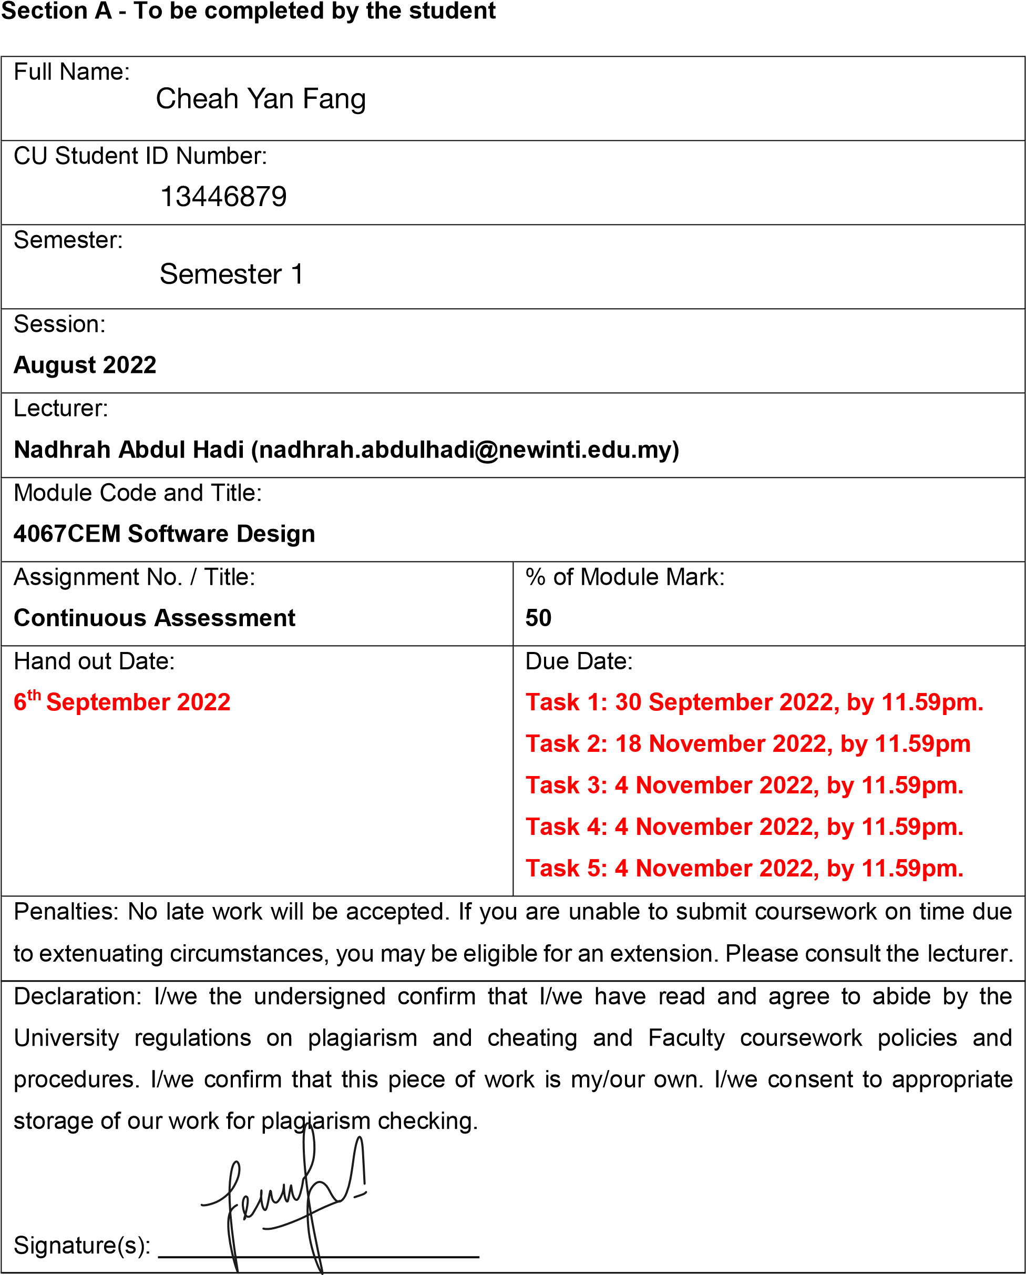

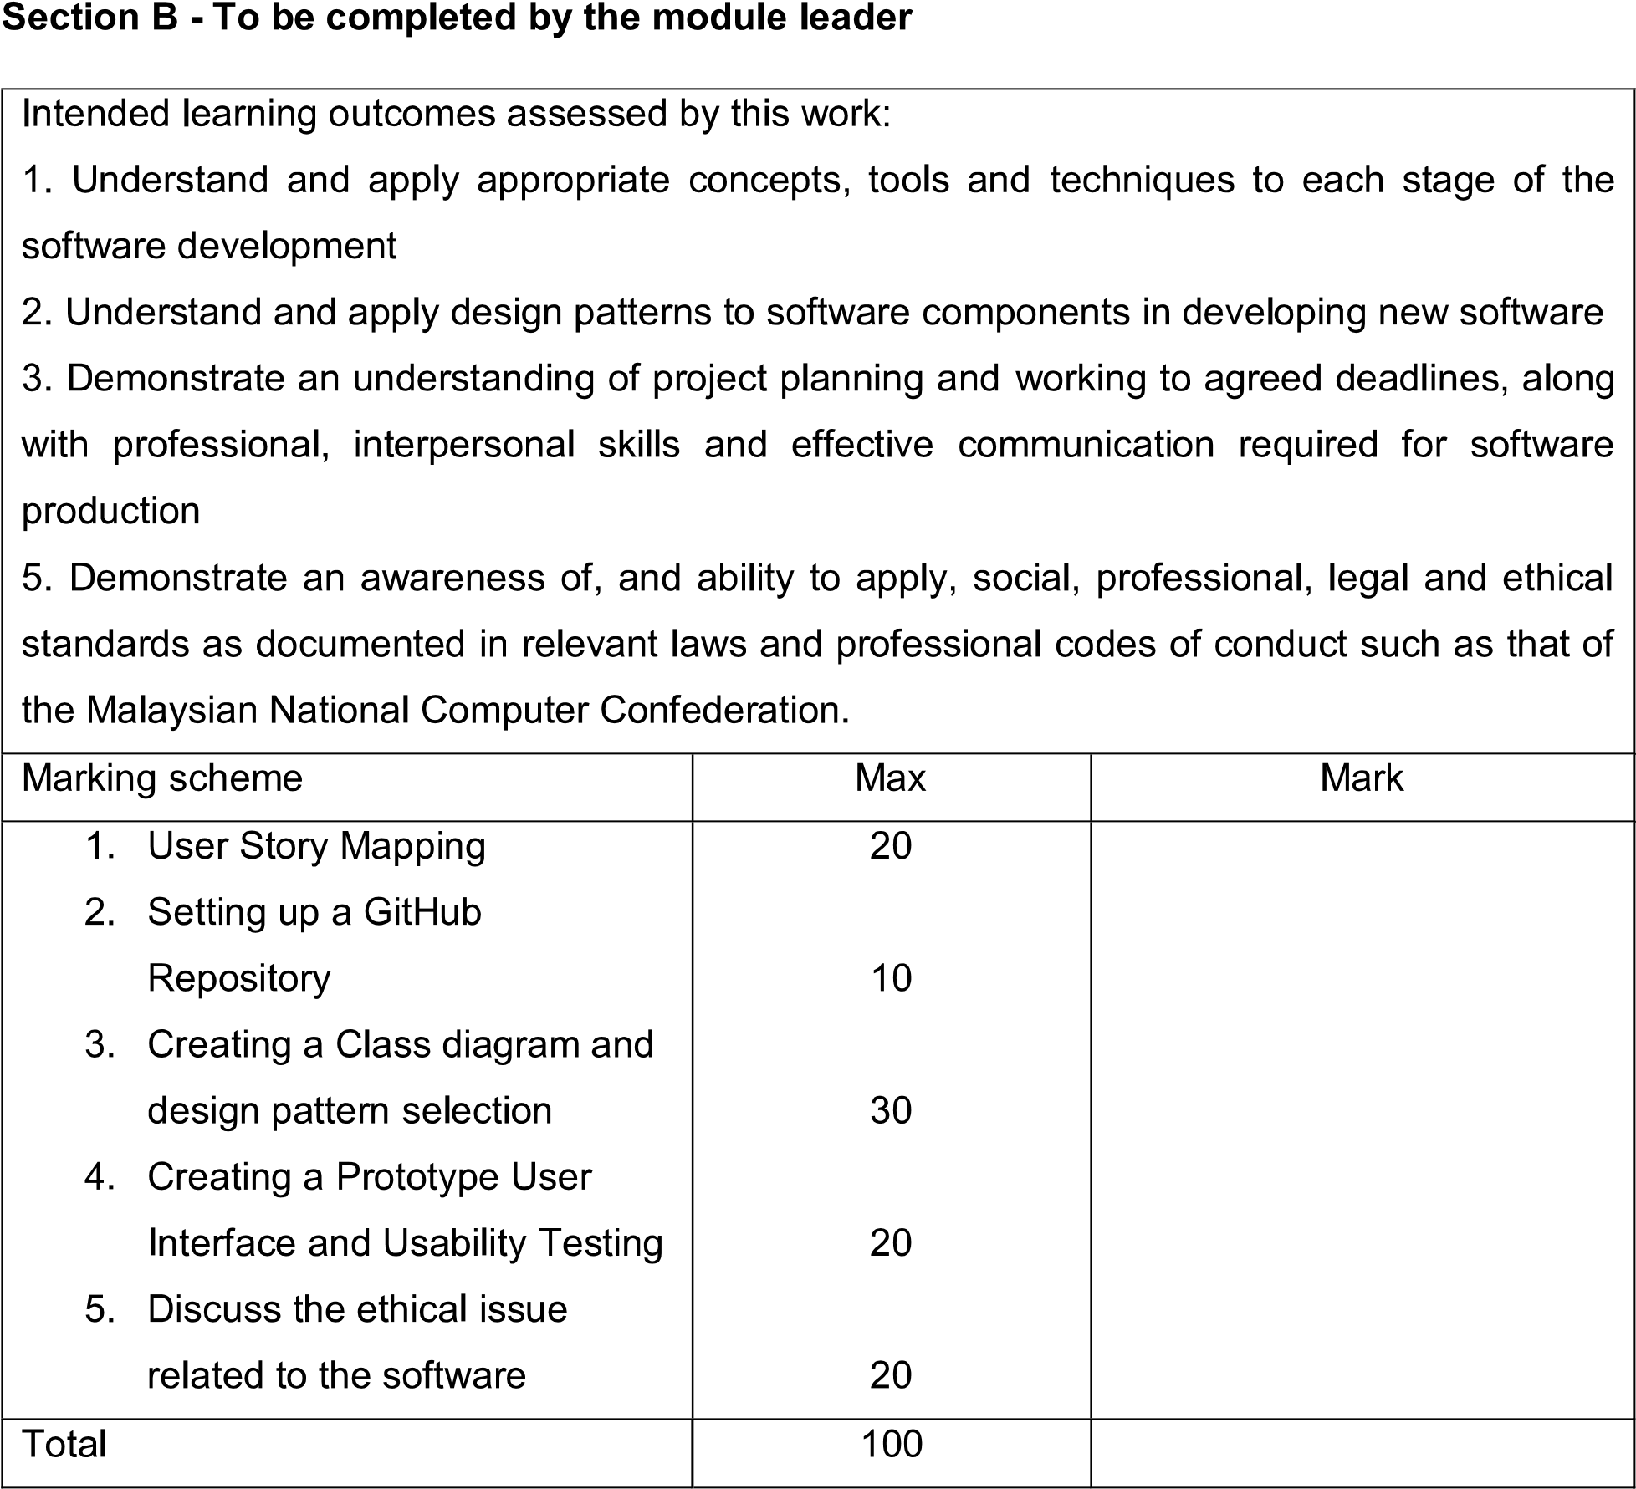

**Task 4 – Creating A Prototype User Interface and Usability Testing**

**Prototype User Interface**

**4.1 Intro**

A buddy system helps to promote friendship, and behavioral and social needs and can foster a greater sense of belonging and a more inclusive school community. This Buddy System is built to allow the students to create a friend-like relationship with one another and be sociable with different cultural backgrounds students within a community. It implements the purpose of increasing social interaction among students in school. This buddy system is created for students that are shy to meet new people. Having this application allows them to be less afraid to approach new people in school by interacting with others with this buddy system application. The students can choose to communicate in-app in the meanwhile of time and meet up later. This enables them to loosen up a bit while interacting in the application before meeting up face-to-face.

**4.2 The Follow and Explore Function**

In this Buddy System, posts uploaded by users/students are called stories. The Explore page shows randomized stories which are uploaded by any users/students each day. As for the Follow page, it inclusively shows the stories which are uploaded by friends who are on the friend list. Basically, the difference between the Explore page and the Follow page is that Explore page may show stories uploaded from any other user, whether is a friend or not a friend in the Friend list, as for the Follow page, only stories uploaded from friends in the friend list are shown. The user/student enable to view, like, and comment on the stories the others shared. Besides, there is one other feature which is the ability to count the views of how many students have seen a particular story.

All users/students are allowed to write descriptions and upload pictures to share their daily stories about school. The Explore page is useful to the greatest extent when there is an event in school. Students can help to promote an event to show the existence of the event via uploading to the Explore page, so students can join their event and take the opportunity to meet others. The user/student can check out the Follow page if the user/student wants to focus on a smaller community and keep track of the latest activities about their closest friends.

Moreover, the user is able to click on the others’ avatar which is placed in the left corner of the picture uploaded by others. Upon clicking the avatar of the others, they will be redirected to the student’s individual feed. One’s feed has the basic information and favorite info about the particular student and all of the stories which have been uploaded in the past. The basic information is consisting of the name, current course of study, and club society. The Favorite information includes the hobby, movies, and food. This information can be used to identify whether or not the particular student has the same preference and characteristics as the user. Last but not least, there is one circular button that might show in two places, one is beside the username, and one is beside the basic information of the student. The button is used to indicate the relationship between both the user and the other students. A tick in the button shows that the particular student is friends with the user, whereas if the button is shown in a plus sign, means the opposite. The plus sign is shown to the user so that the user can send the particular student a friend request to be friends with each another.

`

**Figure 4.2.1 shows the Explore page (left) and the Follow page (right) of the Buddy System**

**Figure 4.2.2 shows that users can view, like, and comment on stories other uploaded**

**Figure 4.2.3 shows that the left feed is not a friend of the user, while the feed on the right indicates the particular student is a friend of the user.**

**Figure 4.2.4 shows that all students can upload new stories.**

**4.3 The Search Function**

The Search function can sort through all the students’ accounts. User can choose to search by different categories in the Search page. The categories are in consists of name, course, hobby, movie, and club. If the user wants to find buddies of a particular course, they can go to the course and type in the name of the course. The all the user having that particular course will pop up immediately. Same for the name, hobby, movie, and club society. So that user can find a person they want to know better and having the same interest and characteristics is quite important which it comes to finding a buddy to be friend with. Upon clicking the rectangular box, the user is redirected to the particular student’s feed.

**Figure 4.3.1 shows the Search page (left) and search by name (right)**

**Figure 4.3.2 shows that user can choose to search by course (left) and by hobby (right)**

**Figure 4.3.3 shows that user can choose to search by movie (left) and by club (right)**

**4.4 Usability Testing**

Usability testing involves evaluating a design's usability with a sample of participants who represent the target audience. It can be performed for numerous kinds of designs and typically includes watching people as they attempt to execute activities. From the beginning of a product's development until its release, it is frequently done repeatedly. Usability testing is done to accomplish objectives including understanding the relative worth of the system, uncover the most crucial features and their significance, as well as what users can do with your system.

|  |  |  |  |  |  |
| --- | --- | --- | --- | --- | --- |
| **Usability Question of the Buddy System** | 1 | 2 | 3 | 4 | 5 |
| Were the functions in the Buddy System easy to understand? |  |  |  |  |  |
| Does the appearance of the application make it pleasant to use? |  |  |  |  |  |
| How helpful do you think to use a Buddy System to make new friend? |  |  |  |  |  |
| Are the details in the Buddy System is organized correctly? |  |  |  |  |  |
| Does the Search function useful for finding the specific person the user expected? |  |  |  |  |  |
| Does this Buddy System fulfil Is the text uniform, clear, and in the proper size? l all the requirements and has all the features the user was hoping for? |  |  |  |  |  |
| Do you think it is good to include both Explore and Follow features in the system? |  |  |  |  |  |
| Is the user redirected to the correct page upon clicking a button? |  |  |  |  |  |
| Is the text uniform, clear, and in the proper size? |  |  |  |  |  |
| Was the overall function of the Buddy System user-friendly? |  |  |  |  |  |

<https://balsamiq.cloud/sf36y0j/pns64s7/r7D5A>

[User Interface 1.pdf](User%20Interface%201.pdf)